EXPERIMENT-8
NAME: RIYA SHARMA ROLL NO: 240701433

AIM:
To design and compare different bus booking mobile app layouts using Balasmiq

PROCEDURE:
- Installed Balasmiq software from the official website.
- Created a mobile canvas with size 1080 × 1920 pixels.
- Designed UI layout including header, search section, and bus listing cards.
- Added UI elements such as text fields, buttons, icons, and navigation bar.
- Organized each component into separate layers for easy editing.
- Created two different layout designs with different color schemes (Light and Dark theme).
- Exported the layouts as PNG images.

LAYOUT DESIGNS:

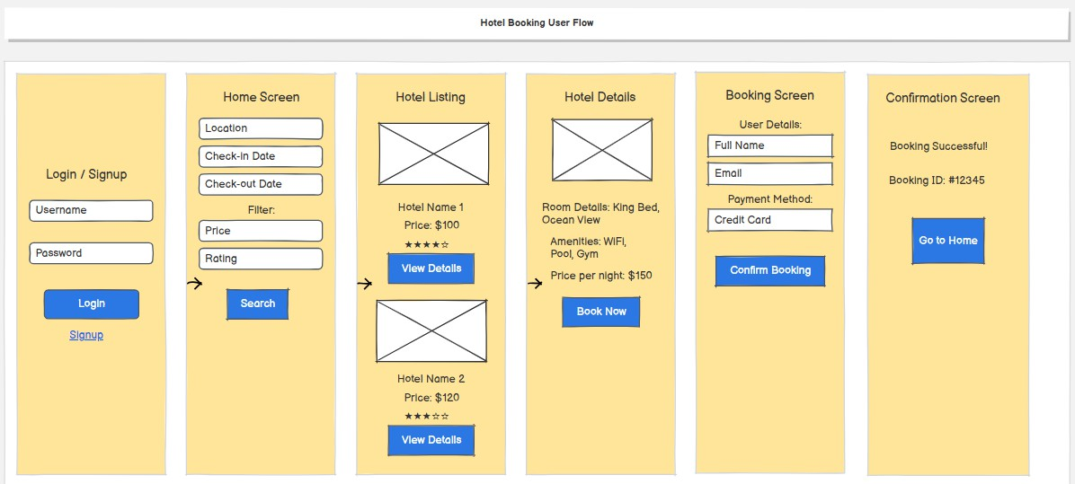

Hotel Booking System – User Flow Document

- Introduction
This document explains the complete user flow of a hotel booking application. It outlines each step a user takes from logging in to successfully booking a hotel room.

User Flow Overview
The system follows this sequence:
Login / Signup → Home Screen → Hotel Listing → Hotel Details → Booking Screen → Confirmation Screen

- Screen-wise Explanation
  - Login / Signup Screen Purpose:
Allows users to access their account or create a new one.

Fields:
    - Username
    - Password

Actions:
    - Login button
    - Signup option for new users

Home Screen Purpose:
Users search for hotels based on their preferences.

Inputs:
    - Location
    - Check-in Date
    - Check-out Date

Filters:
    - Price
    - Rating

Action:
    - Search button → Navigates to hotel listing

Hotel Listing Screen Purpose:
Displays available hotels based on search criteria.

Details Shown:
    - Hotel Name
    - Price
    - Rating (stars)

    - Image (placeholder)

Actions:
    - View Details button → Opens selected hotel details

Hotel Details Screen Purpose:
Provides detailed information about the selected hotel.

Information:
    - Room Details (e.g., King Bed, Ocean View)
    - Amenities (WiFi, Pool, Gym)
    - Price per night

Action:
    - Book Now button → Moves to booking screen

Booking Screen Purpose:
Collects user information and confirms booking details.

User Details:
    - Full Name
    - Email

Payment Method:
    - Credit Card

Action:
    - Confirm Booking button

Confirmation Screen Purpose:
Displays booking success message.

Details:
    - Booking Successful message
    - Booking ID (e.g., #12345)

Action:
    - Go to Home button

Key Features
- User authentication (Login/Signup)
- Hotel search with filters
- Detailed hotel view
- Secure booking process
- Booking confirmation with ID

Conclusion

This user flow ensures a simple and smooth hotel booking experience, guiding users step- by-step from login to confirmation.

